Toolamba PS
Student Engagement Policy

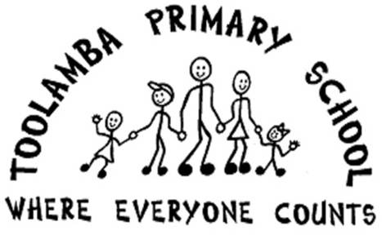

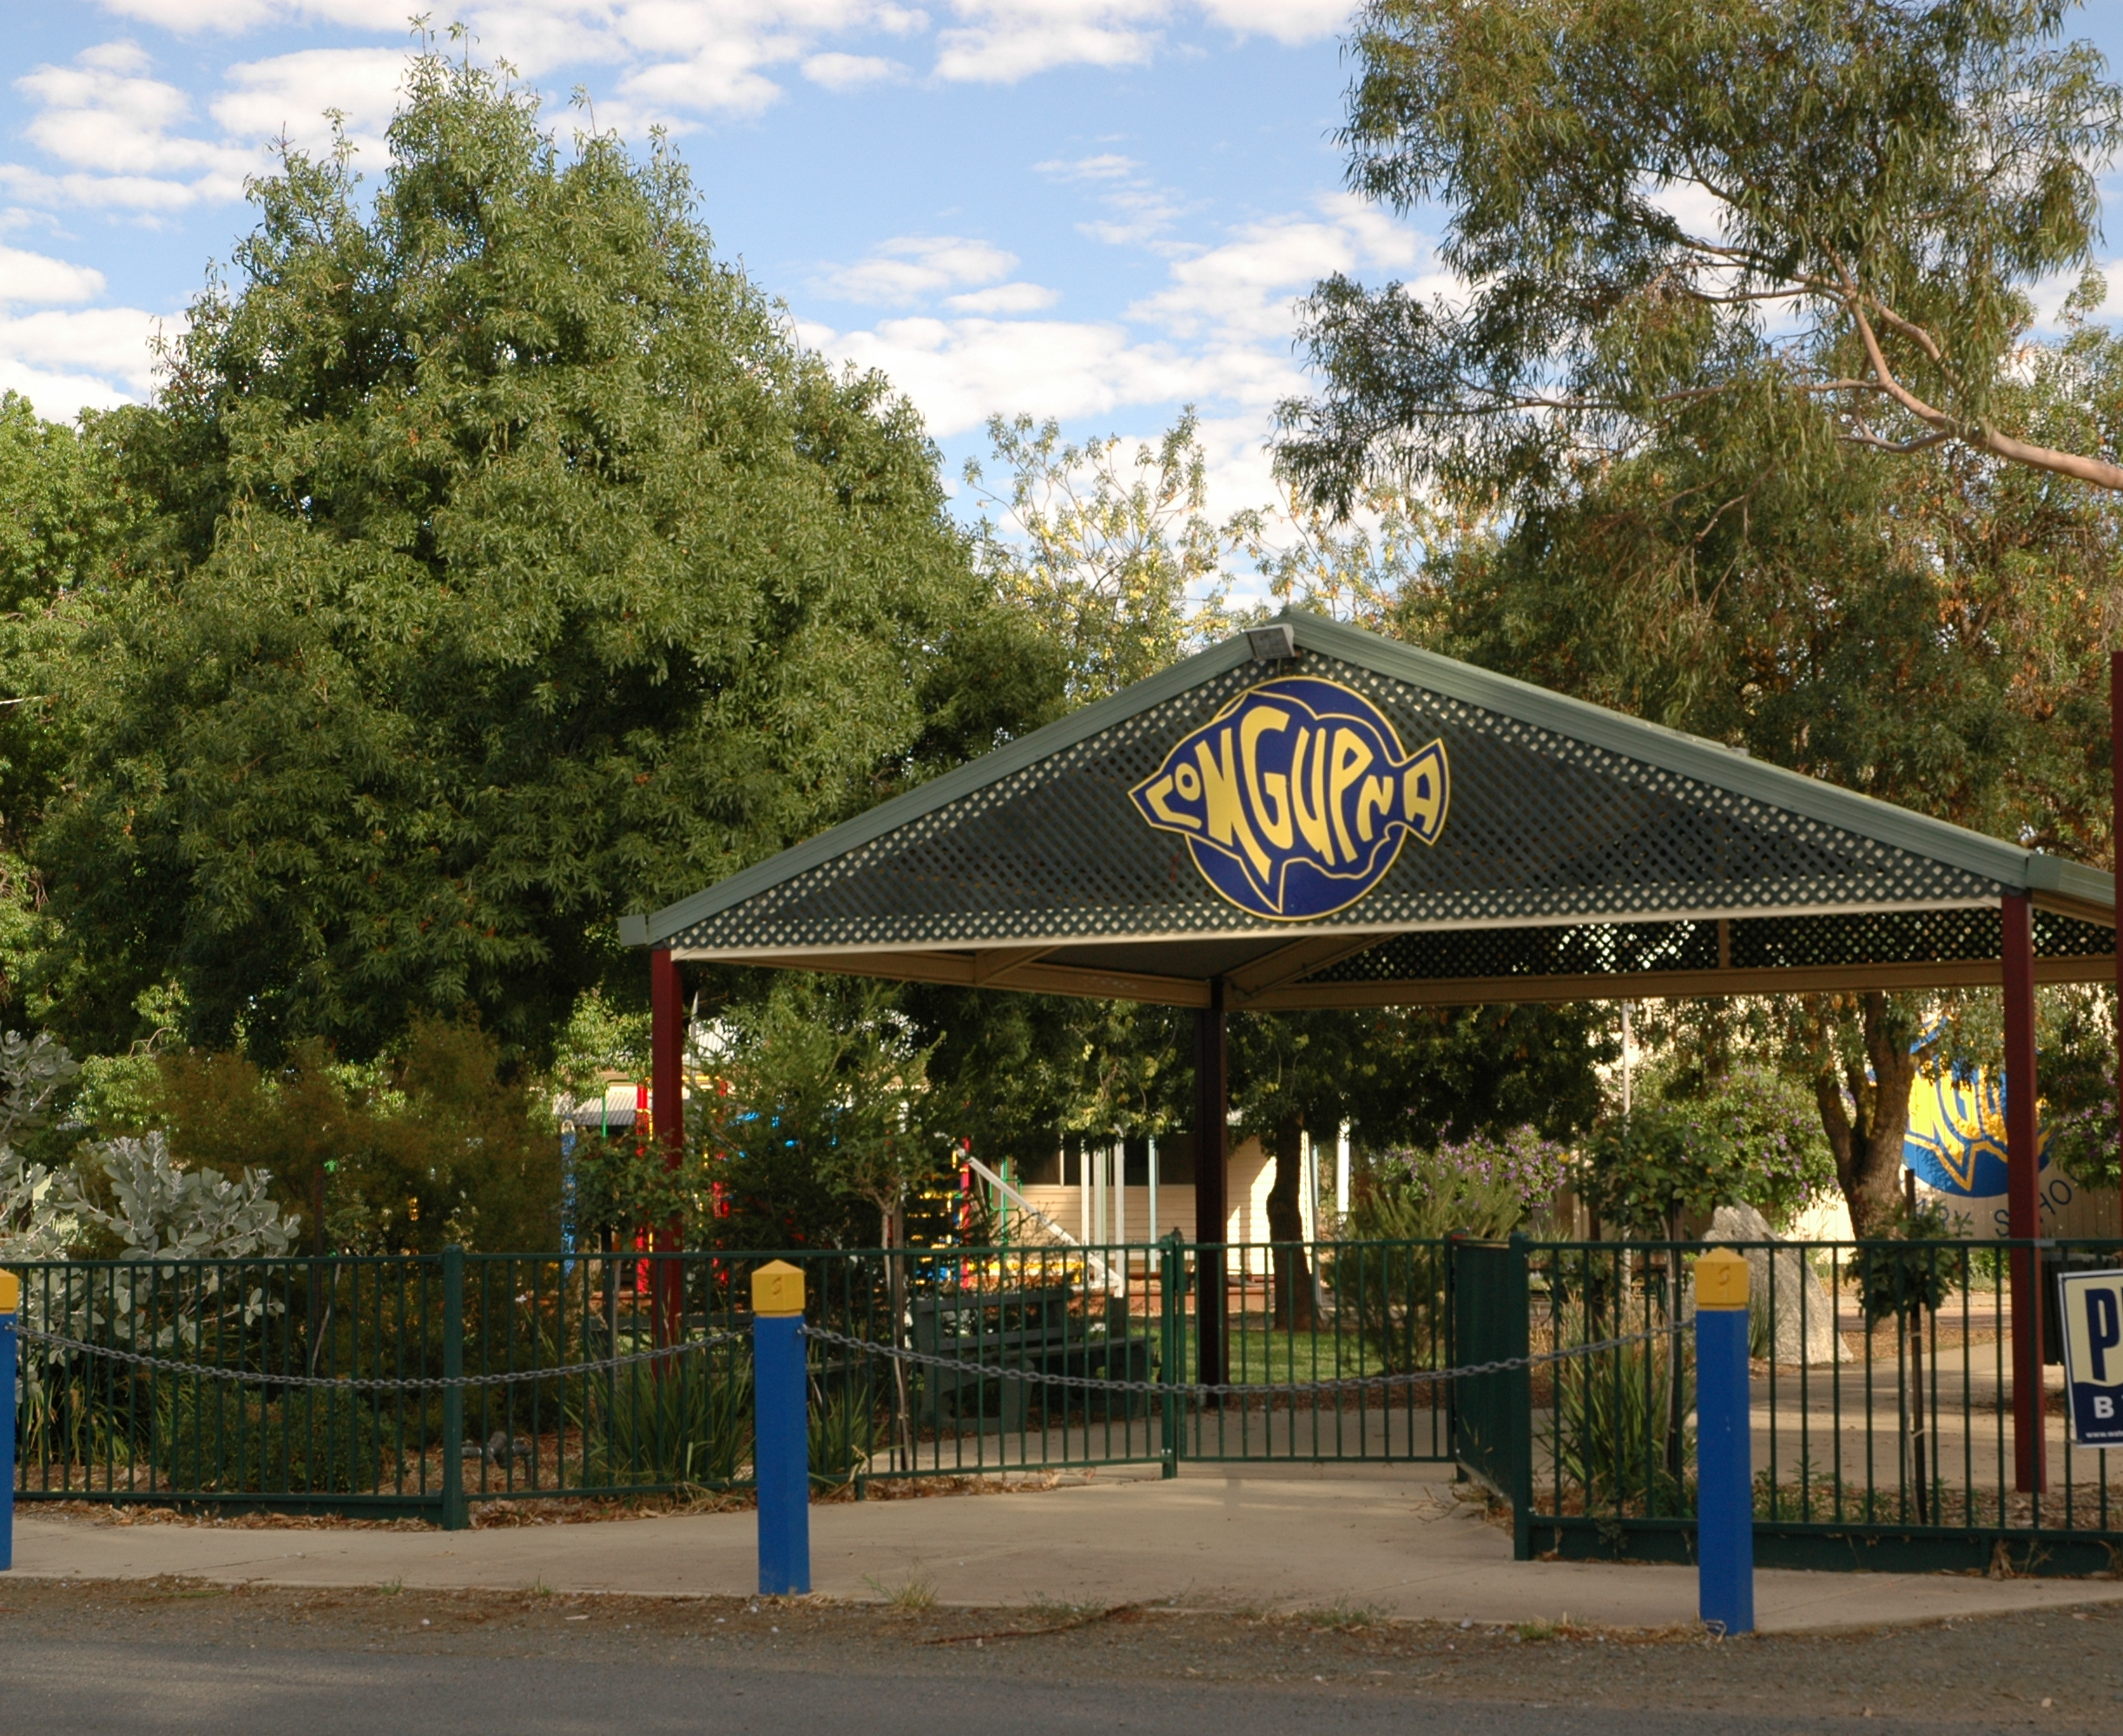

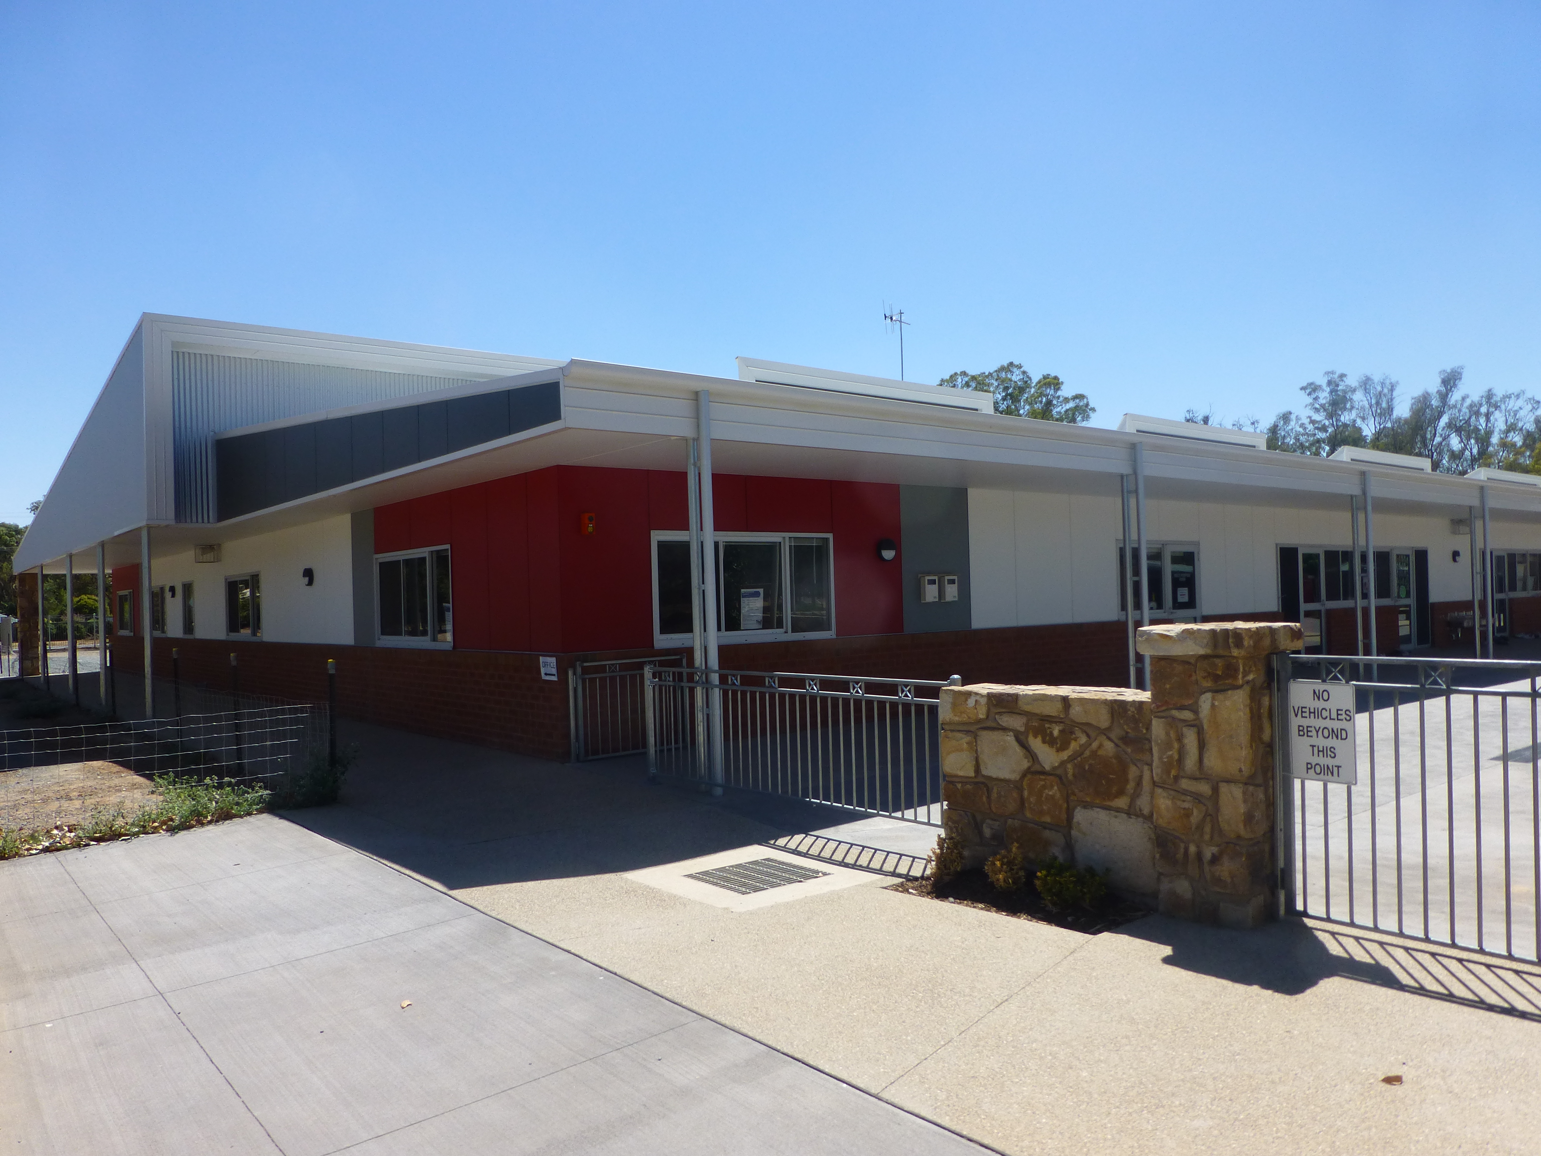

Contents

School profile statement 3

Whole-school prevention statement 4

Rights and responsibilities 5

Shared expectations
– school, parents/carers, students 8

School actions and consequences 10

1. School Profile

Toolamba Primary School is located some 17km to the south of Shepparton. Toolamba, like most country towns is experiencing hardship due to the impact of the drought with many local farmers and fruit growers having reduced production over the last decade..

The Toolamba community pride themselves on the motto ‘Little Town, Big Heart’. Many local events are planned throughout the year and are attended as a community. Toolamba PS has served the familles of the local area since 1874. The 114 students in 2009 come from a socially diverse but culturally homogenous background with farming or secondary processing in the nearby centres of Mooroopna and Shepparton the main parental occupations Students from the town and surrounding areas attend Toolamba PS, the later group travelling to school on one of the two buses

Situated in a community “precinct” that includes a kindergarten, heath and welfare centre, after school care, occasional care, community learning centre, community hall and sporting facilities the school is very much the hub of the town. The onsite kindergarten and family day care enables a smooth pathway from pre-school to Year 6.. The grounds provide for a number of learning opportunities and areas for active and passive play. The outdoor amphitheatre, wetland area, frog bog, chook run and community vegetable garden are testament to the schools commitment to sustainable practices. The school also offers an Active After School Activities Program two nights a week and a daily OSHC centre in our Community Learning Facility.

The staff profile is diverse in term of gender and experience. The three opinion surveys-staff , parent and student highlight the positive learning climate at Toolamba and the subsequent impact on the wellbeing of the whole community. The health organisational survey ranks above 90% of the state primary schools. There is a clear and common understanding of effective teaching and well defined expectations of planning, practice and performance. Parent opinion supports this viewpoint , ranking school improvement at 80% of state primary benchmarks and Toolamba Primary School is proud of its community spirit; it’s caring and nurturing for all, the team work between the Staff, Students, Parents and School Council. The welfare of all students is paramount. We cater for all students and make every effort to ensure students are afforded every opportunity possible.

Our motto, ‘Where Everyone Counts’, is demonstrated by our whole school community. The education of students in our town is shared by the school, the family and the community. We make our facilities available to outside groups, currently being utilized by the Toolamba Cricket Club, Toolamba Auskick and Toolamba Soccer Club.

2. Whole School Prevention Statement

In our school we value our community, our history and our shared vision for the future,
We foster a caring and respectful community where students can learn, grow, contribute and have fun.

Toolamba Primary School is dedicated to catering for the individual needs of all children – educational, physical, social, and emotional. We strive to provide an education for all children that will encourage them to reach their potential. We value the unique worth of each individual.

We stress acceptance of differences, and we emphasise cooperation with, and concern for others.

We seek to provide a challenging and comprehensive curriculum with flexibility to meet the needs of each child. We believe that to be effective, education must be founded on secure mastery of basic skills, taught not only in isolation but also in integration with one another. We place strong emphasis on reading, personal expression of ideas through reading and writing, and the mastery of computational and problem solving skills. We also encourage scientific and technological exploration, artistic creativity, physical activity, and concern for the environment. In every area we aim to develop confidence, self-esteem and social skills, and we stress independent thinking and judgements balanced by receptivity to the ideas of others.

Our school atmosphere is informal and friendly. Parents are welcome and encouraged to participate in all school activities and to become partners with teachers in developing positive educational outcomes for their children.
Teachers at our school are excited about education and are constantly learning and growing. We foster a caring community by working together and supporting and respecting one another. We strive to reach consensus on issues that affect us.
Above all we want children to feel happy, challenged, enriched and nurtured during their time at our school.

Our Key Improvement Strategy for Student Engagement and Wellbeing is to build a strong cooperative learning community that enhances student leadership and citizenship. As a way of achieving this strategy we have implemented several initiatives such as:
- Exploring authentic leadership opportunities.
- Develop the home/school technology link via web page, digital portfolios and links to SharePoint
- Develop healthy and positive lifestyles through You Can Do It Education, shared values and Active After School Program.
- Increase student and parent input into the school and learning through the development of Individual Learning Plans for all students.
- Reduce the numbers of days that students are absent from school by implementing Its not OK to be Away Program and to raise the awareness of the importance of students attending school on the maximum number of days

Our Key Improvement Strategy for Student Pathways and Transition is to develop transition processes Kinder -7 that are supportive and seamless by:
- Track student progress electronically through the use of individual student assessment records and/or portfolios. Respond to individual issues as they arise . Use a mail merge to produce individual student profiles
- Define the expectations of students at critical promotion points (between VELS levels) and develop activities in the lower grades to encourage a successful transition to the higher class and/or secondary school.
- Work with the secondary college to develop curriculum programs and common strategies appropriate to the transition of year 6 to 7
- Develop and implement ability-based pathways, especially for students with talent
- Student induction program for transient students.
- Formalise Kinder-Prep transition.
- Review Primary to Secondary transition program.
- Formalise whole school progressive transition

3. Rights and Responsibilities.
At Toolamba we respect diversity within our school community and promote the values of fairness and equity.

At our school we aim to provide a supportive learning environment through the implementation of a consistent approach to student welfare. The emphasis is on reinforcing and fostering positive student behaviour. Every member of our school community has the right to fully participate in an educational environment that is safe, supportive and inclusive. We believe that everyone deserves to be treated with respect and dignity. The Student Engagement Policy is framed around non-negotiable rights and responsibilities. Every student has the right to feel safe from bullying at school.

We believe that student management is about leading, guiding, encouraging and instructing children within a framework of Rights, Responsibilities & Rules. The Student Engagement Policy is based on the following principles:

Student, Staff and Parent Rights.

All students, teachers and parents have the right to be valued and treated with respect.

Students have a right to:
- Work, learn and play in a secure environment where they are able to develop their talents, interests and ambitions without interference.
- Be treated and spoken to fairly and respectfully by teachers, students and parents.
- Express ideas and opinions in a positive way and to be listened to and respected for them.
- Have equal access to school equipment and teacher time.

Teachers have the right to:
- Teach in an atmosphere of order and cooperation.
- Be treated with respect by students, parents and colleagues.
- To work in a happy, safe, secure and satisfying environment.

Parents have a right to:
- Expect that their children will be educated in a secure environment in which care, courtesy and respect for the rights of others are encouraged.
- Feel valued and respected
- Be shown courtesy and cooperation and to be welcomed
- Participate in a happy, safe, secure and satisfying environment
- Be informed about their child’s progress

Student Responsibilities

- To uphold the shared values of our school which are being respectful, friendly, and trustworthy and a displaying good sportsmanship.
- Allowing others to work without being distracted ensuring the completion of activities and expectations.
- Always having respect of self and others
- A responsibility to be ambassadors of Toolamba PS when on excursion and entertaining guests at our school
- Be courteous and respectful to all people involved in school programs.
- A commitment to ourselves to strive for personal and educational excellence and build self esteem and independence

Teacher Responsibilities

- To uphold the shared values of our school which are being respectful, friendly, and trustworthy and a displaying good sportsmanship.
- A responsibility to ensure that all students are safe and happy in their school environment.
- A responsibility to treat all children, parents and colleagues fairly and respectfully.
- A responsibility to promote an environment, which maximises the opportunity of all students to strive for excellence.
- A responsibility to provide and promote positive role models for students at all times.
- Provide opportunities for all students to experience personal success
- A responsibility to inform parents of their child’s performance at school.
- A responsibility to treat all children equally, regardless of gender, race or religion.
- Arrive at school on time, prepared for effective teaching.
- Contribute to the development of units of work through effective planning and sharing.
- Display consistency when dealing with student management issues both in and out of the classroom.
- Discuss and remain consistent with our school rules and high expectations
- Principal and Staff have an obligation to implement the Student Engagement Policy fairly, reasonably and consistently.

Parent Responsibilities

- To uphold the shared values of our school which are being respectful, friendly, and trustworthy and a displaying good sportsmanship.
- A responsibility to ensure your child attends school.
- A responsibility to support the school in its efforts to maintain a positive teaching and learning environment.
- Being aware of school rules and encouraging acceptable social behaviour.
- Provide the school with current up to date contact information.
- Ensuring your child has enough sleep at night and that they are provided with breakfast before attending school each day.
- Support the schools homework and reading at home philosophy.
- Ensuring your child wears correct school uniform.
- A responsibility to communicate all matters that may affect your child’s learning.
- Parents have an obligation to support the Principal and Staff in their efforts to maintain a productive teaching and learning environment

School Rules
At the beginning of the year each classroom, after discussion between students and teachers, develops some guidelines for behaviour which reflect the rights and responsibilities of students. Following is an example of the rules for each classroom.
In order to achieve a respectful, happy, safe and clean learning environment we have decided on the following rules;
- We respect other people and their property.
- We Stop Look and Listen when someone is speaking.
- We keep our hands and feet to ourselves.
- We move safely between and around the classroom.
- We put up our hands when we require assistance or wish to speak
- We will take pride in our school environment
- Our classroom is a “NO PUT DOWN ZONE”
- We stay within the school boundaries.
- We treat other people how we would like to be treated
- We care for school property.

4. Shared Expectations
Staff, students and parents at Toolamba PS have the responsibility to act in a way that builds on respectful relationships.
RESPECT | Students | Teachers | Parents/Carers
Punctuality | - Show respect by arriving at class on time and completing work on time.  - Arrive at meetings on time.  - Line up on time  - Arrive in time for school, excursions, sports  - Return forms before due date | - Can show respect by arriving on time to class.  - Returned corrected work promptly  - Get to work on time  - Arrive at meetings on time | - Can show respect by supporting their child to be on time to class each day  - Arriving at school events and meetings on time.  - Return forms before due date  - Signing readers
Attendance | - Show respect by attending school each day. | - Ensure that students and parents are aware that regular school attendance is one of the major factors contributing to a student’s wellbeing and success.  - Monitor individual student attendance consistently  - Alert the school administration promptly when concerned about student attendance.  - Liaise closely with parents and guardians regarding enhancement of student  - Follow staff protocols to report illness to ensure a CRT is employed | - Can show respect by supporting their child to be at school each day and valuing the education program  - Parents aware that regular school attendance is one of the major factors contributing to a student’s wellbeing and success.  - Parents phone the school or send a note if children are absent
Use good manners | - Can show respect for students and teachers by being trustworthy, polite and caring.  - Speak nicely about other people  - Saying please and thank you  - Not interrupting conversations  - Using inside voices  - Listening to others  - Not swearing  - Respect is not talking when someone else is talking.  - Respect is people being polite to one and another  - Say hi and bye  - Smile at people  - Share with others  - Respect is looking at the teacher when talking and not talking when he or her are talking.  - Saying please and thank you. | - Treat parents/students /and fellow staff members with respect  - Listen to others  - Saying please and thank you  - Not swear  - Respect each other’s property, space by asking permission to borrow things or use equipment.  - Respect is looking at the person who is talking and not talking when he or she is talking.  - Respect is people being polite to one and another  - Say hi and bye  - Smile at people  - Saying please and thank you. | - Be nice to teachers and students  - Be polite  - Not swear when students are around  - Respect is looking at the person who is talking and not talking when he or she is talking.  - Respect is people being polite to one and another  - Say hi and bye  - Smile at people  - Saying please and thank you.
Learning | - Students show respect for their learning by always striving to do their best  - Check over work carefully  - Complete work to the best that you can  - Read every night  - Do homework  - Use time wisely  - Try not to get distracted  - Keep workspace eg lockers and pigeon holes clean and tidy | - Can show respect for student learning by providing lessons which engage and scaffold student learning.  - Have the resources needed for lessons.  - Not talking on the phone in class.  - Match the learning to the student | - Make sure readers are signed  - Help with homework  - Talk to kids about their learning  - Value learning, not putting it in the bin.  - Encourage kids to do work.  - Acknowledge student portfolios by completing blue reflection sheet
Communication | - Can ask for help or ask questions.  - Talk to teacher immediately if there is a problem causing distress. | - Provide timely communication to parents regarding their child’s progress and listen to parents insights into their children’s learning  - Communicate with staff members by adding to calendar, special dates or leaving message on whiteboard in staffroom | - Communicate clearly with the school about the needs of their children.  - Phone to make an appointment when you have a concern  - Communicate positive feedback on child’s progress and wellbeing at school.  - Voice concerns with teachers, not other parents
Yourself | - Respect is allowing 2nd chances.  - Respect is making your own decisions not any one else’s.  - Respect is never being afraid of being of being your self.  - Having a go at all activities  - Caring for yourself and for others tidy uniforms  - Owning up to your mistakes  - Being the best you can be  - Try new things | - Feel comfortable to express opinions without intimidation  - Talk to colleagues when feeling anxious/stressed.  - Respecting and valuing ourselves, thereby enabling us to respect ad value others. | - Feel comfortable about approaching teachers with concerns.
Others | - Talk to people the way you would like them to talk to you.  - Take care of the younger students  Um help someone pack up something or help someone in trouble  - Always listen to others  - Share  - Don’t tell secrets about other people  - Be kind and friendly to others, and treat them how you would like to be treated.  - Involve other people  - Allow second chances  - No bullying | - Talk to people the way you would like them to talk to you.  - Always listen to others  - By offering to help and working as a team.  - Developing positive relationships with students and teachers through empathy and respect  - Treat parents with consideration and regard, respecting other peoples point of view  - Value contributions made by each member of the community  - Cooperate and be team player | - Talk to people the way you would like them to talk to you.  - Always listen to others  - By offering to help and working as a team.  - Treat teachers with consideration and regard, respecting other peoples point of view  - Value contributions made by each member of the community  - Cooperate and be team player
- Environment | - Can show respect by valuing school property and surroundings.  - Care for sports equipment  - Care for garden equipment by putting it away after we use it  - Care for books  - Keeping the school and classroom tidy  - Not putting tape on walls  - Return books to school  - No graffiti  - Recycle materials  - Turn off lights  - Attend working bees  - Pick up rubbish  - Respect is cleaning up after your self.  - Caring for belongings yours and other peoples  - always ask before you borrow someone’s things  - Respect is looking after other peoples belongings.  - Respect is giving 100% at ALL lessons.  - Have a go even if you can’t do it.  - Make sure after lunch and recess all sports equipment is away. | - Can show respect by valuing school property and surroundings.  - Looking after school equipment.  - Teaching children how to care for our environment.  - Keeping the school and classroom tidy  - Not putting tape on walls  - Encourage children to care for the environment, give opportunities to do this.  - Attend working bees  - Show respect by recycling.  - Conserve power and resources | - Can show respect by valuing school property and surroundings.  - Attend working bees  - Residents of Toolamba report incidents at the school eg after hours, weekends and holidays  - Be aware of children’s activities at school after hours and encourage them to respect property  - Show respect by recycling.
- School Rules | - Can show respect by following school rules, school policies. Can also show respect by observing their rights and responsibilities.  - Respect is owning up to things you did wrong.  - Respect is telling the truth. | - Review school polices to ensure they maintain a safe and secure environment for students. e.g. Bus Policy, Internet Users Policy  - Be consistent about enforcing rules and their consequences.  - Care for natural habitats and wildlife. | - Support the school in the implementation of the school rules, code of conduct and school policies.  - Ensure children are wearing the correct school uniform

5. School Actions and Consequences
A STAGED RESPONSE

- Prevention (Whole School) focuses on proactively preventing the development of new cases of problem behaviors by focusing on all students and staff, across all settings (i.e., school-wide, classroom, and non-classroom/non-instructional settings).
- Early Intervention (Targeted) focuses on reducing the number of existing cases of problem behaviors by establishing efficient and focused responses to problem behavior.
- Intervention (Intensive) focuses on reducing the intensity and/or complexity of existing individual cases of problem behavior that are resistant to primary and secondary prevention efforts.
We have a multifaceted approach to student engagement and wellbeing which includes the use of a range of preventative strategies including; restorative practices, the Bully Busters program , Behaviour Management Plans, Student Support Groups, Rational Emotive Behaviour Therapy, You Can Do It Education, Wilson Mc Caskill Games and the use coordinated Student Support Services.

Preventative Strategies:
Preventative strategies support the development of a positive school climate where students are encouraged to develop self discipline and be responsible for their actions. It is important that we maintain an environment that is supportive, tolerant and caring for all students. When disruptive behaviour occurs it is necessary to respond positively and effectively.
Toolamba Primary implements the following strategies to help develop a positive school climate:

- Use of positive reinforcement. ie. Praise, awards, stickers, special activities.
- Social skills training to develop self esteem.
- Use of multi-age classrooms and cross-age activities to develop tolerance and awareness of individual differences in students.
- Further development of playground and sports equipment to encourage students to engage in organised physical activity during recess times.
- Use of cooperative learning techniques to reinforce to students that all contributions are respected and valued.
- Common purpose & approach to discipline
- Clear set of positive expectations & behaviours
- Procedures for teaching expected behaviour
- Continuum of procedures for encouraging expected behaviour
- Continuum of procedures for discouraging inappropriate behaviour
- Procedures for on-going monitoring & evaluation
- Teachers consult with students to develop classroom rules and consequences for desirable and undesirable behaviour.
- Open communication with parents when difficulties arise.
- The utilisation of external agencies when the situation arises.

Restorative Practices.
The fundamental aim of our behaviour management philosophy and practice is for students to learn to be responsible for themselves and their actions and to make genuine, positive contributions to their community. We use a restorative approach which sees conflict or wrong-doing firstly as an opportunity for students to learn about the consequences of their actions, to develop empathy with others, and to seek to make amends in such a way as to strengthen the community bonds that may have been damaged.
We do this by:

    - having high expectations and insisting upon high standards of behaviour, and
    - providing high levels of support and care for individuals
A Restorative approach...
- encourages students to appreciate the consequences of their actions for others
- enables students to make amends where their actions have harmed others
- requires students to be accountable for their actions
- encourages respect for all concerned

Bully Busters Program
Bullying is when someone, or a group of people, upset or create a risk to another person's health and safety - either psychologically or physically - or their property, reputation or social acceptance on more than one occasion.
There are three broad categories of bullying.
- Direct physical bullying e.g. hitting, tripping, and pushing or damaging their property.
- Direct verbal bullying e.g. name calling, insults, homophobic or racist remarks, verbal abuse.
- Indirect bullying - This form of bullying is harder to recognise and often carried out behind the bullied student’s back. It is designed to harm someone’s social reputation and/or cause humiliation. Indirect bullying includes:
  - lying and spreading rumours
  - playing nasty jokes to embarrass and humiliate
  - mimicking
  - encouraging others to socially exclude someone
  - damaging someone’s social reputation and social acceptance
  - cyber-bullying, which involves the use of email, text messages or chat rooms to humiliate and distress.

What bullying is not
Many distressing behaviours are not examples of bullying even though they are unpleasant and often require teacher intervention and management. There are three socially unpleasant situations that are often confused with bullying:
Mutual conflict - In mutual conflict situations, there is an argument or disagreement between students but not an imbalance of power. Both parties are upset and usually both want a resolution to the problem. However, unresolved mutual conflict sometimes develops into a bullying situation with one person becoming targeted repeatedly for ‘retaliation’ in a one-sided way.
Social rejection or dislike - Unless the social rejection is directed towards someone specific and involves deliberate and repeated attempts to cause distress, exclude or create dislike by others, it is not bullying.
Single-episode acts of nastiness or meanness, or random acts of aggression or intimidation - Single episodes of nastiness or physical aggression are not the same as bullying. If a student is verbally abused or pushed on one occasion they are not being bullied.
Nastiness or physical aggression that is directed towards many different students is not the same as bullying. However, since the school has a duty of care to provide a student with a safe and supportive school environment, single episodes of nastiness or physical aggression should not be ignored or condoned
Bullying is a behaviour, which is defined as a repeated action – physical, verbal, psychological or social by those in a position of power on those who are powerless to resist, with the intention of causing distress for their own gratification.
As part of our whole school approach to student engagement and wellbeing the school has adopted the principles of the Bully Busters Program .The program is based on two main strategies, prevention and intervention.
Children come away from the program with assertive strategies and tools for building resilience and confidence.

The aim of the program is to:
- Identify bullying behaviour
- Engage students in responsible reporting
- Activate bystanders to take safe and sensible action
- Build resilience into children to be free of victim thinking
- Provide students with a repertoire of assertive strategies
When an incident of bullying has been reported a Method of Shared Concern is adopted. The Method of Shared Concern is not focused on fact finding or assigning blame. The aim is to find solutions in a non-confrontational manner that enables the bullied student and the bully to co-exist.
Students or parents who have concerns regarding bullying are encouraged to discuss the matter with their class teacher.

Cyber Bullying
Young people have fully embraced the use of information and communication technologies to maintain contact with friends and make new ones. With many families having access to the internet children are able to send emails, create their own websites, post personal news in blogs (online interactive diaries), send text messages and images via mobile phones, message each other through IM’s (instant messages), chat in chat rooms, post to discussion boards and seek out new friends in community sites.
While most interactions are positive, there are increasing reports of these technologies being used to harass and intimidate others. This has become known as cyber bullying.
Toolamba PS has the responsibility to ensure that:
- We use appropriate programs that are safe and restricted.
- All forms of cyber bullying are prohibited at Toolamba PS.
- Staff are aware of cyber bullying and are able to identify and look for signs of its occurrence among students.
- Students are aware of the consequences of cyber bullying.
- Specific rules are in use for technology, including computers and mobile phones, whilst on the school premises.
- All cases of cyber bullying are reported to the Principal and responded to promptly.
- There is supervision of technology that is effective for monitoring and deterring cyber bullying.
Students at Toolamba PS have the responsibility to ensure that they:
- Do not participate in cyber bullying.
- Do not use mobile phones, cameras or other digital devices to record audio and visual material that is not authorised as part of the school curriculum program.
- Do not breach the privacy of students, staff and members of the school community through any unauthorised recording or filming.
- Do not disseminate inappropriate information through digital media or other means.
- Report incidents of cyber bullying to a member of staff.
- Advise students being victimised by cyber bullying to talk to an adult.
You Can Do It Education.
The 'You Can Do It!' Education aims to provide all children with the foundations for achievement and social-emotional well-being in school, work, and the world of tomorrow.
Our core value is the development of the potential of all children (academically, intellectually, interpersonally and emotionally) through instilling in children 5 Foundations - Confidence, Persistence, Organisation, Resilience and Getting Along. Research indicates that these foundations determine the extent to which children achieve and experience social, emotional and behavioural well-being.

Central to the development of these 5 foundations is explicit instruction in 12 Habits of the Mind. Research indicates that these determine the extent to which children achieve and experience social, emotional and behavioural well-being. The Positive and Negative Habits of The Mind (an extended component of the 5 You Can Do it Foundations) are also covered in these sessions and incidentally during classroom sessions and in the playground. They are: Accepting Myself, Taking Risks, Being Independent, I Can Do It, Giving Effort, Working Tough, Setting Goals, Planning My Time, Being Tolerant of Others, Thinking First, Playing By The Rules and being Socially Responsible

Rational, Emotive Behaviour Therapy R.E.B.T.
On occasions children are confronted with challenges when working/playing. The process of REBT is used at these times. Students work on a one to one basis with a teacher.
The aims of REBT sessions are:
- To help students become aware of negative, irrational thoughts and beliefs, which lead to
- unhealthy, destructive feelings and behaviours.
- To explore with students rational, emotive and behavioural skills which assist them in
- learning to deal with difficult situations in a constructive, useful and healthy way.

Consequences.
Breach of school rules.

- Verbal reminder/s of appropriate behaviours.
- Discussion around the school value which is being breeched.
- If behaviour continues – time out at recess or lunch when students are given an opportunity to make a positive contribution to the school community.
- This is supervised by teacher on duty, class teacher or principal and consequences if the behaviour continues.
- Behaviour recorded in consequence book and signed off by person supervising activity.
- Students may be asked to complete work that has been unfinished due to their behaviour and depending on the student’s age or skill; they may be asked to complete a Behaviour Reflection Sheet (student improvement plan).
- Severe behaviour will result with children being exited from the room or yard immediately to the principal’s office.
- All breaches of rules that require a consequence will be recorded on Primstar.
- Parents will be notified through either a phone call (priority) or letter if their child has been removed from class or the yard and any incident that warrants parent notification.
- Persistent or serious behaviour problems will be dealt with through consultation between the class teacher, parents and the Principal. Outside agencies will be employed where appropriate.

Code of Conduct for School Leaders.
At Toolamba PS we encourage students to accept positions of responsibility and leadership within the school. School Captains, Vice Captains Bus Captains, House Captains and Junior School Councillors are expected to be good role models and display appropriate behaviour.
On appointment to their position all school leaders sign an agreement to abide by qualities attributed to their role in the school.

When a school leader receives an office referral for inappropriate behaviour, the following will occur:
1st – Office Referral: Warning of future consequences regarding loss of position.

2nd Office Referral: Area of responsibility withdrawn for one week and badge handed in. Students are given opportunities to demonstrate their commitment to the role
3rd Office Referral: Parent interview conducted and responsibility withdrawn for one week and badge handed in.
4th Office Referral: Students area of responsibility withdrawn for the remainder of the year.. Badge handed in.

Behaviour and Consequences

RIGHTS | RULES | NEGATIVE CONSEQUENCES | POSITIVE CONSEQUENCES
Students have the right to learn and achieve. | - We do not distract others in class.  - We respect each others property.  - We complete our work quietly and to the best of our ability | 3 Step Process  - Verbal reminder/s of appropriate behaviours and consequences if the behaviour continues.  - Time-out in classroom recess/lunch)  - Sent to school office/principal (Detention) | Verbal praise  Awards/certificates  Stickers  Public recognition at assemblies and in the Newsletter
Teachers have the right to teach without interruptions. | We follow teacher’s instructions.  We are punctual, we enter the room in an orderly manner and we are organised and ready for work at the appropriate times.  We use manners-please, thank you etc. | 3 Step Process  - Verbal reminder/s of appropriate behaviours and consequences if the behaviour continues.  - Time-out in classroom recess/lunch)  - Sent to school office/principal (Detention) | Verbal praise  Awards/certificates  Stickers  Public recognition at assemblies and in the Newsletter
Students and Teachers have the right to feel safe-emotionally and physically. | We do not hurt another person physically or emotionally.  (Fighting, bullying, swearing, teasing or any form of aggressive behaviour is not permitted and will not be tolerated).  We do not use behaviour that is offensive, degrading or insulting to others.  Dangerous items must never be brought to school. | - Removal from class/yard  - Exit to office  - Possible suspension | Verbal praise  Awards/certificates  Stickers  Public recognition at assemblies and in the Newsletter
Students have the Right to be part of the Toolamba community. | We must respect and take care of all school property.  Vandalism or theft will not be tolerated.  We wear tidy and correct school uniform every day.  All food is eaten in the appropriate areas and  all rubbish is put in the bin. | - Removal from class/yard  - Exit to office  - Possible suspension  - Intentional damage must be repaired or replaced.  - Note sent home for repeat offenders  - Reminder of school rules.  - Yard duty picking up papers. | Verbal praise  Awards/certificates  Stickers  Public recognition at assemblies and in the Newsletter
Students have the right to play and feel safe in the yard. | We stay in the school grounds at all times.  We remain outside of the school buildings before and after school and during recess and lunch unless we have permission.  We do not climb on roofs, trees, fences or parts of the school buildings.  We play co-operatively and by the rules of the games we play  We do not play in the toilets, garden beds breezeways or climb trees  We wear our hats in terms 1 and 4 | - 3 Step Process  - Verbal reminder of appropriate behaviours and consequences if the behaviour continues.  - Student to accompany the yard duty teacher for a time determined by the teacher on duty  - Removed from yard to school office/principal. (Detention)  - No Hat-No Play  - Children directed  - to covered areas. | Verbal praise  Awards/certificates  Stickers  Public recognition at assemblies and in the Newsletter

A Staged Response
Positive behaviours are most effectively supported through relationship based whole-school and classroom practices. However, Toolamba PS recognises that some individuals and groups of students require additional support in the development of pro-social, positive behaviours. For most of these children and young people, the development of prosocial behaviour is achieved in stages, and requires reinforcement and acknowledgement to support each step towards positive improvement. Students with problem behaviours can be responded to through a staged response

Stage 1& 2: Prevention and early intervention
Implementing preventative and early intervention strategies to support positive behaviours is a key part of Toolamba’s Student Engagement Policy.
We strive to:
    - define and teach school-wide and classroom expectations
    - establish consistent school-wide and classroom consequences for problem behaviour
    - establish school-wide and classroom processes for early identification of students experiencing academic and/or behaviour difficulty
    - provide school-wide and classroom processes for ongoing collection and use of data for decision-making
    - empower students by creating multiple opportunities for them to take responsibility and be involved in decision-making
    - provide a physical environment conducive to positive behaviours and effective engagement in learning
    - utilise evidence-based interventions, monitored regularly for those students who face difficulty with learning and/or behaviour.

Stage 2: Intervention
When concerns arise about a student’s behaviour, or when a student is displaying chronic patterns of problem behaviour, we adopt a more targeted response to support the student. We ensure that:
- targeted interventions are based on systemic collection and analysis of data(Use of communication book and Primstar.
- progress is monitored via the Behaviour Management plan which is developed by Student Support Group.
Student Support Group
The student support group aims to:
- develop an understanding of the child or young person
- utilise data collection and monitoring systems that will inform decision-making
- identify the child or young person’s learning, social, emotional, behavioural and environmental needs, and the support or resources the student requires for improvement
- involve key specialist learning and wellbeing support staff, for example the literacy coach, student welfare coordinator, primary welfare officer, reading recovery teacher and/or school psychologist
- develop an Individual Learning Plan with the student’s classroom teacher/s and ensure support to implement the plan
- support referrals to community support agencies for specialist interventions delivered in partnership with the student support group school strategies.
Meetings of student support groups must involve:
- school principal (or delegate)
- student (as appropriate)
- student’s main classroom teacher, the form/home-room teacher or the
- year level coordinator
- parents/carers
- professionals who have been supporting the student or their family, for example the student welfare coordinator, psychologist, youth worker etc
Parents/carers may be accompanied and supported by a advocate at a student support group meeting. Parents/carers are required to organise the attendance of this support person, who cannot act for a fee or reward.
The role of the advocate is to provide emotional and moral support to the student and/or their parents/carers, and to act as a witness to the process of the student support group. The support person should attend only as an observer, and should refrain from directing the process or answering questions on behalf of the
student or their parents/carers. The only circumstances in which the advocate should speak on behalf of or participate in the student support group is when a language or communication barrier has been previously identified by the student, their parents/carers or the school.

Suspension
A principal may suspend a student if, while attending school or travelling to or from school or engaged in any school activity away from the school (including travel to or from that activity), the student:

- Behaves in such a way as to threaten or constitute a danger to the health, safety or wellbeing of any person; or
- Commits an act of significant violence against a person or causes significant damage to or destruction of property; is knowingly involved in the theft of property; or
- Possesses, uses, or deliberately assists another person to use prohibited drugs or substances; or
- Fails to comply with any reasonable and clearly communicated instruction of a principal, teacher or other staff member; or
- Consistently behaves in a manner that interferes with the wellbeing, safety or educational opportunities of any other student; or
- Consistently engages in behaviour that vilifies, defames, degrades or humiliates another person based on age; breastfeeding; gender identity; impairment; industrial activity; lawful sexual activity; marital status; parental status or status as a carer; physical features; political belief or activity; pregnancy; race; religious belief or activity; sexual orientation; personal association (whether as a relative or otherwise) with a person who is identified by reference to any of the above attributes.
- A student can be suspended for up to a maximum of 5 days at any one time.
- A student who is suspended requires a support person.
- Expulsion will become an option when every avenue of support has been exhausted.

In determining whether to suspend a student, the principal must ensure that suspending the student is appropriate to:

- the behaviour for which the student is being suspended
- the educational needs of the student
- any disability or additional learning need of the student
- the age of the student
- the residential and social circumstances of the student.

Expulsion
The principal is responsible for student expulsions. This responsibility cannot be delegated to any other person at the school. Expulsion from a school is the most extreme consequence open to the principal. When expulsion is unavoidable, principals have a responsibility to demonstrate that expulsion is the only appropriate measure and that all other measures consistent with a staged response and the Student Engagement Policy have been implemented in good faith by the school
without success.
Grounds for expulsion
A principal may expel a student if, while attending school or travelling to or from school or engaged in any school activity away from the school (including travel to or from that activity):
- the student does anything for which they could be suspended
- the student’s behaviour is of such magnitude that, having regard to the need of the student to receive an education compared to the need to maintain the health, safety and wellbeing of other staff and students at the school and the need to maintain the effectiveness of the school’s educational programs, an expulsion is the only available mechanism.
In determining whether to expel a student the principal must determine
- that expulsion of the student is appropriate to:
- the behaviour for which the student is being expelled
- the educational needs of the student
- any disability or additional learning needs of the student
- the age of the student
- the residential and social circumstances of the student.
- Regional Director must be notified that expulsion is being considered
- Regional Director’s nominee attends student support group to discuss expulsion
- Copy of the Procedures for Expulsion brochure and the Expulsion Appeal Proforma must be provided to the student and their parent/carer at the student support group

